**EXERCISE 4: SQL BUILT IN FUNCTIONS**

# Create an EMPLOYEE Table with the following attributes

**EMPID, EMPNAME, JOB, DOB, SALARY, DEPTNO, GENDER**

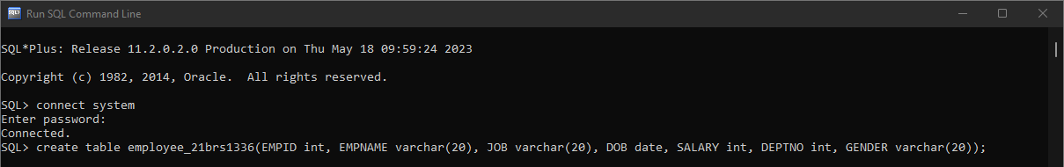

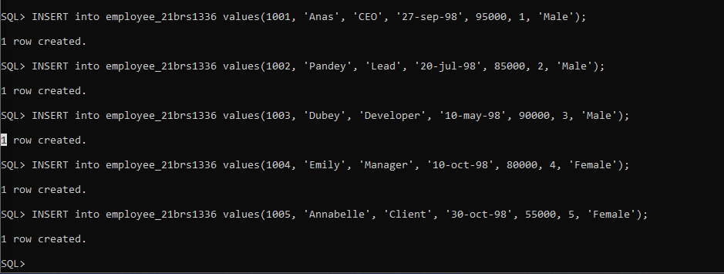

**Write queries for solving the following:**

1. Calculate the square root of the salary of all employees.

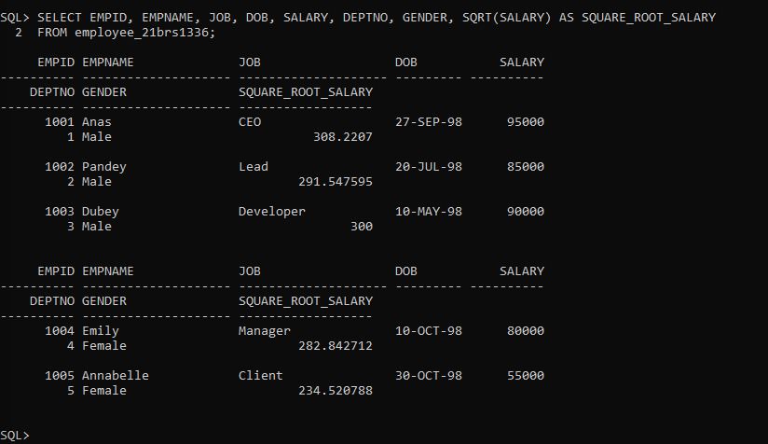

1. Apply any other five numeric built in function to ‘salary’ attribute of employee table

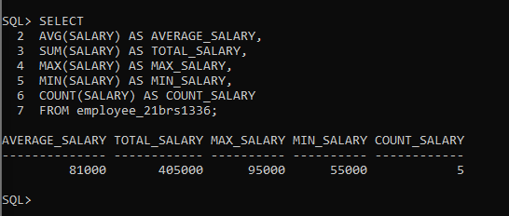

1. Extract only the first 5 characters of the employee names.

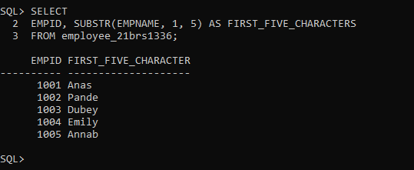

1. Apply any other five string built in function to ‘name’ attribute of employee table

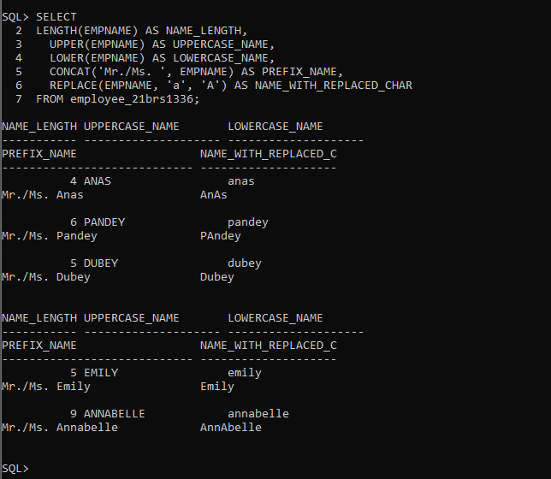

1. Determine the max and min salary and rename the column as max_salary and min_salary.

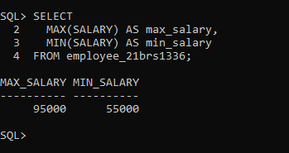

1. Display the month name of date “14-jul-15” in full.

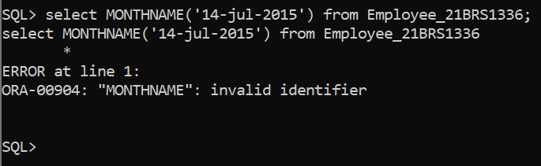

1. 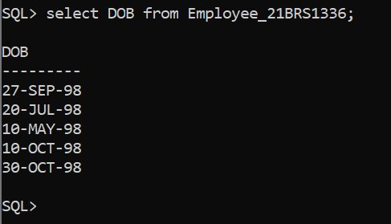Display the Dob of all employees in the format “dd-mm-yy”.
2. Display the date two months after the Dob of employees.

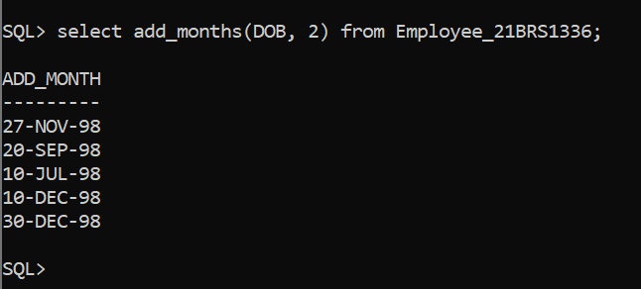

1. Display the last date of that month in “05-Oct-15”.

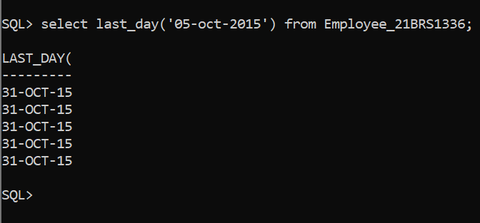

1. Display the rounded date in the year format, month format, day format

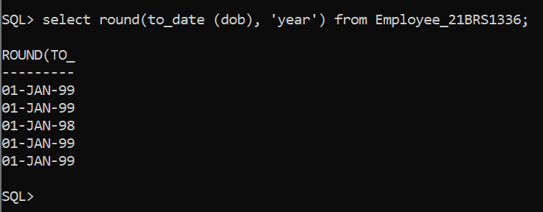

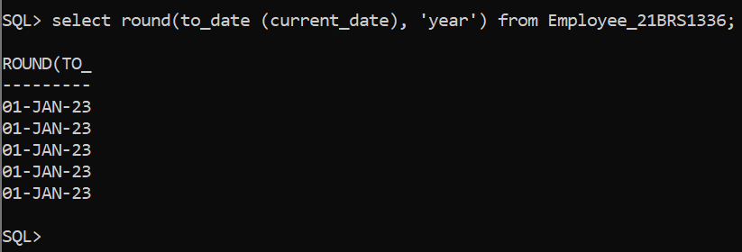

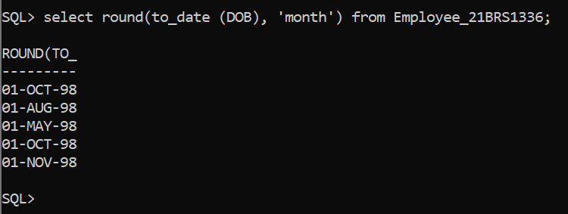

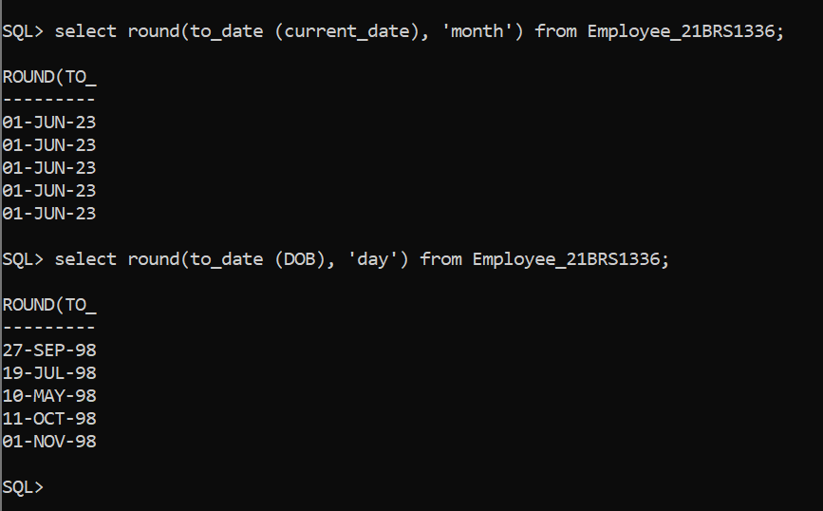

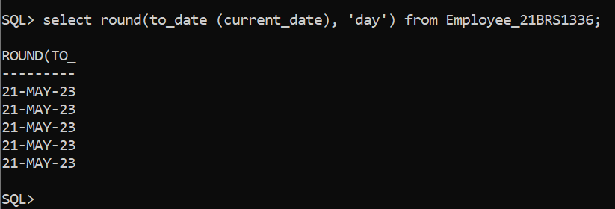

1. Display the date 60 days before current date.

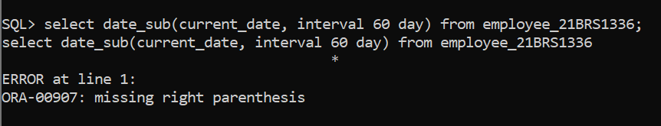

1. Display the names and dob of all employees who were born in August.

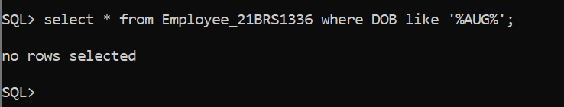

1. List out the employee names who will celebrate their birthdays during current month.

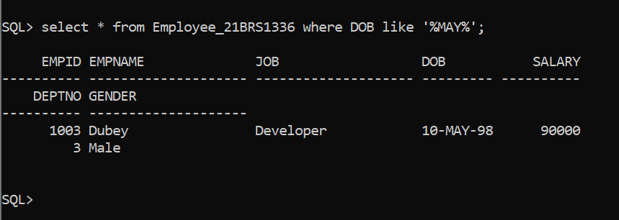

1. List all female employees who were born April

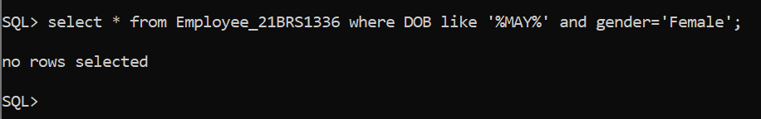

1. What is the difference between maximum and minimum salaries of employees in the organization?

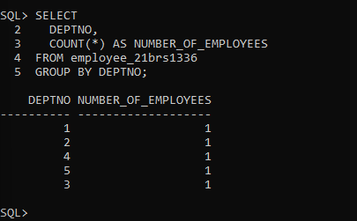

1. Display number of employees working in each department and their department name.
2. Display total salary spent for employees.

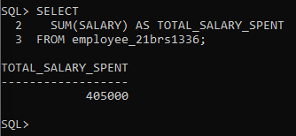

1. Display total salary spent for each job category.

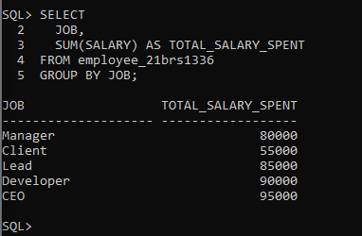

1. Display lowest paid employee details under each manager.

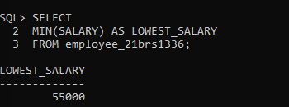

1. Find how many job titles are available in employee table.

